





PLM Interest Group

FUTURE PLM PREVIEW

REPORT

Structured ideas for the
‘Big PLM Rethink’.

Version 1.0

17 August 2026

INTRODUCTION
The PLM 2025-35 Project was devised in 2025 to raise the level of PLM by establishing a Vision for the next 10 years and building a global Body of Knowledge that can be used to achieve it.
As part of its formation in 2026 it published the State of PLM 2026 Report, which highlights how PLM has fallen behind the pace of modern manufacturing; and the State of PLM 2026 Position Statement explaining how the PLM industry should address this.
The aim is to form a Steering Group made up of bring proactive organisations from all parts of the spectrum to review the situation, evaluate the future needs and possibilities, and produce a PLM Blueprint for the next decade.
Any re-evaluation of PLM will need fresh ideas if we are not to perpetuate ‘more of the same’, and on Tuesday 11 August the PLMIG hosted the Future PLM Preview Forum to do just that.
The two-hour session opened with Vendor Keynote presentations intended to show the advanced concepts they were working with (rather than a sales pitch of their product range), leading to a group discussion that expanded on those ideas.
The format was very successful, and thanks should go to the presenters for rising to the challenge so quickly. The ‘blitz’ presentation format was obviously not enough time to explore their subject in any depth, but worked very well in terms of stimulating new thought.
This was an ideas session, so comments and discussions in this document are about the ideas presented, not about products. The conversation went much further than anyone expected, as participants built on each other’s observations, and it fleshed out the scenario that the Future PLM Steering Group will have to address.
This is the Report.

Table of Contents
0 INTRODUCTION 2
1 KEYNOTE – VIOLET LABS 4
1.1 Background 4
1.2 Data Connective Tissue 4
1.3 Concept Development 5
2 KEYNOTE – EXP SOFTWARE 6
2.1 Background 6
2.2 Agentic Digital Twin 6
2.3 Concept Development 7
3 KEYNOTE – MAINSTREAM VENDORS 8
3.1 Background 8
3.2 Advancement of PLM 8
3.3 Concept Development 9
4 LESSONS FROM 2005 10
5 TOTAL VIEWPOINT OF PLM 11
5.1 Why? 11
5.2 What Is It? 11
5.3 What It Does 11
6 CHANGING THE FUTURE 12
6.1 Re-Thinking 12
6.2 Resolving 12
6.3 Re-Solutioning 12
7 NEXT STEPS 12

KEYNOTE – VIOLET LABS

Background
Violet Labs was formed out of frustration with the explosion of tools not talking when dealing with the explosion of data in modern manufacturing, and have based their approach on dealing with this.

Data Connective Tissue
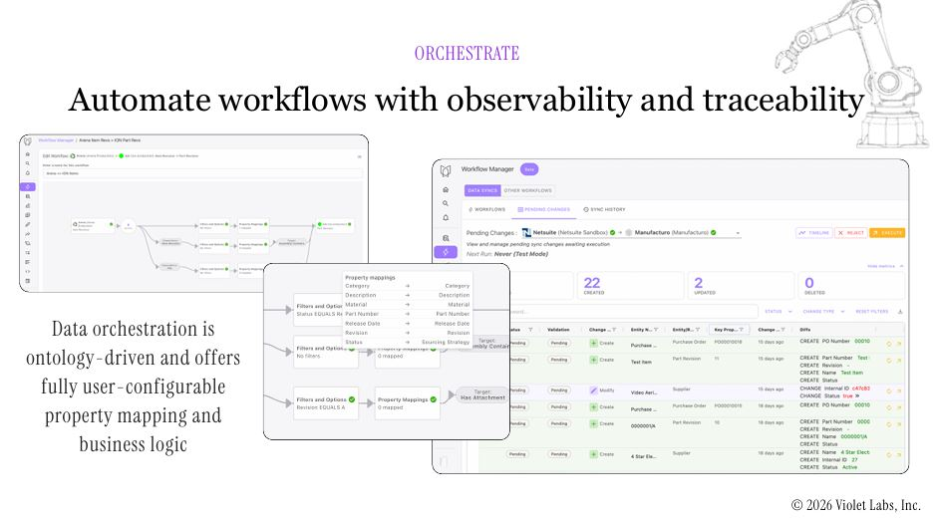
The approach steps back from traditional PLM elements of functional teams working on disconnected systems, replicating cross-functional data and spending time on the process rather than the task - and instead puts the data first.

By establishing an ontology for scalability and correctness, applying configurable business logic, and working via the MCP Model Context Protocol standard, all of the silos of data can potentially be reached and made accessible for the AI tools.
This enables Violet to become a hub for functional integration, synchronisation and automation across the lifecycle. Dashboarding and reporting enable business decisions to be made, and built-in validation ensures data integrity.
As PLM and other systems are encompassed within this enterprise-wide data environment it offers the potential to provide the management and control that PLM once aimed for.

Concept Development
This is a promising way forward, though it should be seen within the context of a total viewpoint of PLM.
The concept is almost a great piece of lateral thinking – rather than focusing on the complexities of PLM, what if we had total, intelligent control of the data in all its repositories across the enterprise, together with a control console to steer it?
If we set it up and manage it the way that the business needs, does that achieve PLM from the ground up – with the added benefit of no more spreadsheets and siloed data?
The answer is that it doesn’t, though it may be a way of advancing PLM in the face of its everyday complexities. The missing part is that PLM works from the Enterprise Down: i.e. it starts with business needs (do we make products, how do we make them accurately, do we even need computers to do this?).
Data connective tissue integrates what already exists, in a way that may be extremely valuable, but does not reveal whether the existing capabilities are necessary, or others are now needed, or whether the overall environment is progressing towards long-term aims.

KEYNOTE – EXP SOFTWARE

Background
EXP Software take the static Digital Twin concept and uprate it with Agentic AI so that it becomes live.

Agentic Digital Twin
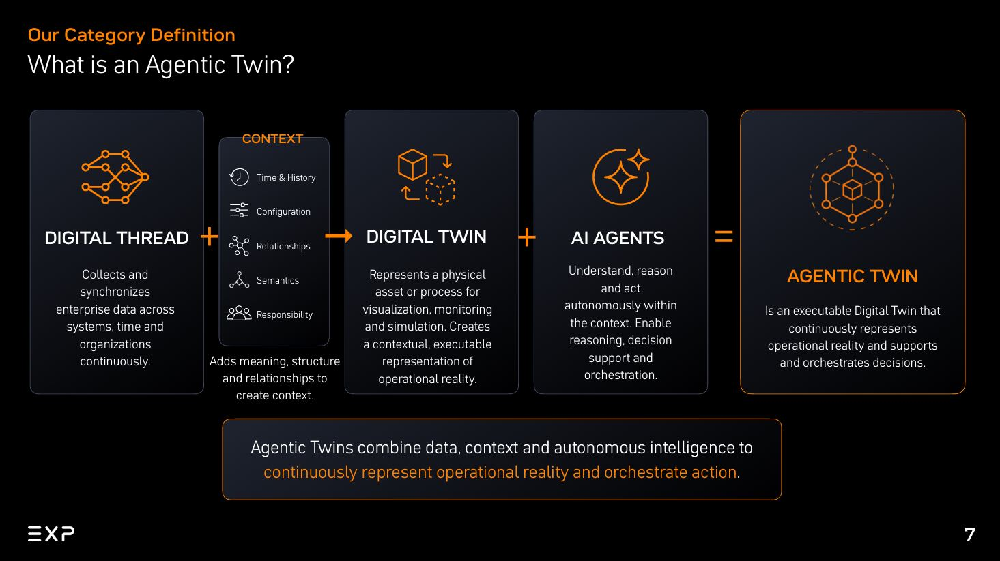
Most Digital Twins today are modelled manually, system by system, with data copied in which means it is almost immediately stale. Variants and configurations are simplified and history cannot be reconstructed.

An Agentic Twin is derived automatically from source systems, stays connected and configuration-aware, and every state is historized and traceable. This needs an AI agent that can perceive, plan and act, checking results and correcting course.
The agent acts on enterprise states rather than flat datasets, deriving context, state and history while seeing and doing only what it is allowed to. Data stays where it is, and meaning is added on top. Systems of record (PLM, MES, ERP) remain the masters.
Not only does the Agentic Twin continuously represent operational reality, but it can do what Digital Twins were always supposed to – stay current and live after the product is sold. Customer interactions using the correct portal are also built into the model, so the Digital Twin ages alongside the physical product.

Concept Development
This is a promising way forward, though it should be seen within the context of a total viewpoint of PLM.
It is a powerful and possibly transformative solution for its technical niche, in that it resolves the primary difficulty: a Digital Twin that does not continually modify in the same way as its physical counterpart is not really a Twin, but a model that was congruent at one point in time.
As well as the reasoning and decision support features of AI, the Agentic Twin has the potential to reach along the Customer Chain and keep itself alive and accurate. There is further to go with this. A farmer buying replacement parts through the correct portal will update the Twin, but a ship captain berthing at a port for emergency repairs may not. An AI-based ‘update agent’ working through the MCP interface might be able to determine for any modification which supplier Twin on the boat needs to be updated and how. Perhaps Future PLM needs this as a new standard functionality.
The other viewpoint shortfall applies to all AI-based solutions, and it is that any given agentic solution does not consider what other agents may be running. Before any PLM manager considers an AI application, the first question is: “Who else in this company is working on AI, and what are they doing?”
Answering this question first means that you work with your company’s experts (rather than learning for yourself), and can map the way that AI agents interact to foresee likely consequences.

KEYNOTE – MAINSTREAM VENDORS

Background
The mainstream PLM vendors are the bedrock of PLM development as it happens in the marketplace. The enhancements they feed into their massive installed bases are the main enablers for progress and evolution.

Advancement of PLM
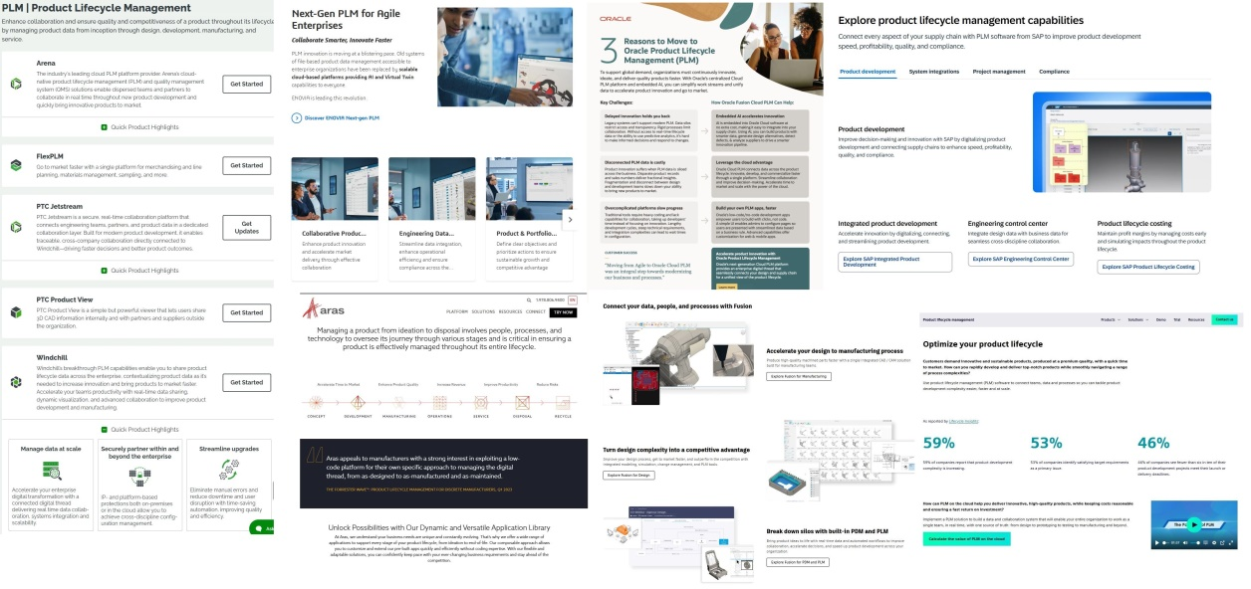
This illustration is a montage of snapshots from six or seven of the main vendors’ PLM web pages, and you don’t need to read them to know what they say.

They all look very similar, talking of enhancing product innovation, dynamic visualisation, managing the product through its lifecycle, accelerating the design-to-manufacturing process, providing an enterprise digital thread, connecting every aspect of the supply chain, and working as a single team with one source of the truth.
All of which is good, but all of which could have been said twenty years ago. They look like# empty shop windows, which nobody really expects customers to see.
For this Forum we were looking for a mainstream vendor Keynote that would present fresh ideas about Advanced PLM, and there is reason for optimism here – one of the main vendors did offer, and had an interesting line of thought to propose, but we were defeated by the holiday season. The session lost one of the threads we were aiming to pursue, but we are hoping to build on this as we go forward.

Concept Development
Mainstream vendors may be the way forward, but their message lacks a total viewpoint of PLM.
This is one of the main things missing from the web pages – they list product features and well-known generic benefits rather than taking the viewer through the PLM thought process, motivating them en route.
It is fair to say, by extension, that vendors are not nurturing the market. Trade shows and vendor events try to enthuse by showing future product enhancements or “what our users have done so far” rather than leading the way with where we should go next.
This is a major lost opportunity, because mainstream vendors have had large development teams working continuously over two decades, which represents thousands of man years of focused effort. The 80:20 rule means that not all of it is adopted by the customer base, and it would be good to see their more future-oriented lines of thought guiding the industry.
It is also a loss because revisiting the total viewpoint of PLM allows everyone to rethink aims and possibilities, which tends to spark new projects that more than compensate for any rationalisation.

LESSONS FROM 2005
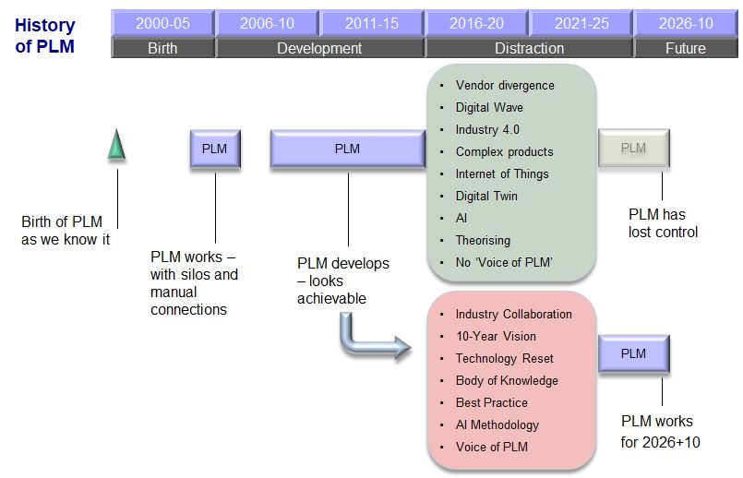
In order to reacquaint ourselves with the total viewpoint of PLM, it is useful to go back to 2005.
In 2005-06, about five years after it first became a recognised concept, PLM was working. Yes it was rudimentary, but then so was the technology. Despite this there was general understanding about ‘business-before-technology’ and a common view about where everything would be heading when the technology caught up.
For about ten years it did look as if the technology was catching up. PLM systems became more capable, user corporations developed massive in-house knowledge, and it looked as if everything was going in the right direction.
And then it gradually fell apart, mainly because everyone lost focus on PLM itself and started to focus on details and side issues, all of which seemed important at the time. The Digital Wave, Industry 4.0, and Internet of Things are among the many distractions, while in the meantime real PLM has withered.
This is where we are. PLM has become complex because it is overgrown like an unattended lawn.
We can get back to the clarity of thought that we had in 2005, and bring it forward to the world of 2026 by industry collaboration: restating a future Vision, resetting the use of technology, developing neutral knowledge and best practice, and yes, getting the benefits of AI. We can get PLM that works now and 10 years into the future.

TOTAL VIEWPOINT OF PLM

Why?
The State of PLM 2026 Report of 08 June showed that PLM needs a rethink, from the ground up. It is behind the curve of modern manufacturing and will never catch up unless we review what it is for, and how that is achieved.
This Future PLM Preview Forum has offered ideas about what might be included in such a rethink, but has also highlighted the need to return to PLM aims and principles.
If we don’t revisit the fundamental reasoning, then PLM is condemned to become ever more complex. It becomes an endless the ‘Evolve and Add’ approach. If we just add a new generation of tools to solve the problems, they become part of the larger mix, and potentially create new legacy systems out of things that are currently working well. The way to dissolve complexity is what could be termed the 'Big Rethink’.

What Is It?
The easiest way to visualise it quickly is to imagine that all your computers have disappeared, and you have to do everything by logic and explanation. You still have all the PLM tasks to do, across the lifecycle and throughout the enterprise, but now you must know why you are doing them and try to optimise for least effort and most effect. Then add the computers back in and see how well it all fits.

What It Does
It is a chance to step back and take a fresh look at what PLM is all about. Instead of trying to rationalise the current tangled web, we can go back to what we knew correctly in 2005 and bring it up to date.
By revisiting the Total PLM Viewpoint and working backwards and outwards, existing implementations are seen in a new light; new options and improvements are revealed; and the way forward becomes much clearer.

CHANGING THE FUTURE
This two-hour session could touch on only a very few of the many issues that need to be resolved to bring PLM up to date. Rethinking PLM constructively needs the input of all industry stakeholders, including vendors across the spectrum (which is what we have been looking at here); users who want to rationalise and refresh their implementations; and integrators and consultancies that want to work with educated clients.
The mechanism is the Future PLM Steering Group, working together in a Round Table format to rationalise, streamline and regenerate the current confused situation.

Re-Thinking
Over the course of 12 months the Future PLM Steering Group will carry out a collaborative review of how the PLM industry has progressed, and where it needs to improve to match modern manufacturing; and hence produce a PLM Blueprint that will define the scope and direction of PLM over the next 10 years.
The Steering Group gives guidance and direction to the industry that will actually steer the future – and as its Members collaborate they get a host of direct benefits: high-level cross-fertilisation of ideas and methods; a re-appraisal of PLM aims and strategy; visibility of the current and ‘successor’ vendor marketplace; and a stream of ongoing findings from the Body of Knowledge.

Resolving
It is no good defining great new ideas if the tools and methodologies are not there to support them, so the Steering Group also benefits from the PLM Body of Knowledge. The first things to be created for the Body of Knowledge are the solutions to the participants' own problems and issues, so they not only get first view of the techniques but also fixes for their most important headaches.

Re-Solutioning
The ongoing payback, well before the Blueprint, is that the Re-Think enables participants devise better solutions for their own implementations, with a practical re-migration path as the Project runs.

NEXT STEPS
If you would like to know more about the Steering Group or this Report, you can request more information via steering_group@plmig.com.

After seeing the presentation, some of the participants commented that they would like to see something like this for legacy systems.

