

PLM 2025-35
PLM Body of Knowledge





Creating an Industry-Wide Body of PLM Knowledge
The PLM 2025-35 Project aims to develop a global Body of Knowledge that captures the learnings of the past two decades in a neutral, structured and useable form.
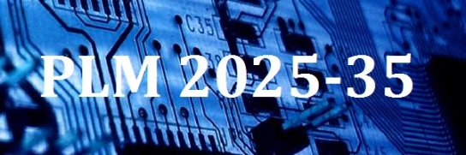
The Project is highly interactive, providing a framework for users, vendors and advisors to combine their expertise and generate specific solutions that are of direct benefit.

With two working streams (User Collaboration and Knowledge Development) there is scope for organisations of all types, and from anywhere in the world, to take part.

Constructive Participation
The setup is entirely practical. Over a 12-month timeframe, user companies collaborate by inputting technical and business issues they would like solutions for. The PLMIG works with the companies respectively and as a group to structure and develop these, and provide working solutions that each company can apply directly. Vendors, consultancies and advisors validate the distilled knowledge and help refine it into an agreed neutral format.

Expression of Interest
Everyone who takes part will want to know how their own issues and aims will be covered, and that is best done by direct discussion. If you would like to find out how the Project could benefit you, without obligation, then please complete and return the form below to plm2025-35@plmig.com.

Name:
Job Title:
Company:
Contact Email:

