





PLM 2025-35
PLM Body of Knowledge

Project Proposal

Version 2.3

12 November 2025

PLM has been a recognised discipline for more than two decades, but the knowledge and expertise gained over that period has never been captured.

The Professional PLM Initiative has highlighted the general lack of progress of PLM over this time, and identified the creation of an internationally-agreed Body of Knowledge as an industry need.

The PLMIG has established the PLM 2025-35 Project as a mechanism for user, supplier, adviser and academic organisations to collaborate in sharing knowledge and structuring it for productive use.

This document is a Proposal for the PLM Interest Group to coordinate and support the creation of a PLM Body of Knowledge over its first twelve months, and explains how organisations of all types can participate.

INTRODUCTION
The PLM 2025-35 Project has long-term aims of establishing an agreed Industry Vision for the next 10 years, and then helping the PLM industry to achieve it.

The first step in this journey is develop a Body of Knowledge that captures the learnings of the past two decades in a structured and useable form. This will not only show the ‘As-Is’ situation (which can then be reviewed and advanced), but will create a reference model that is of direct use to everybody who works in PLM.

This is an entirely practical exercise. The Body of Knowledge project is structured so that user companies can share methods and best practices amongst the participating group, and get specific solutions to the more complex problems and issues that they face.

The learnings are distilled into a neutral format, which is then reviewed and developed by a parallel group of organisations from all parts of the industry.

CONTENTS
This Proposal is set out under the following headings:-

1 INTRODUCTION 2
2 CONTENTS 3
3 BACKGROUND 4
4 HOW IT WORKS 5
4.1 Principle 5
4.2 Framework 6
5 METHODOLOGY 7
5.1 User Collaboration 7
5.2 Knowledge Development 8
6 AI WORKING GROUP 9
7 BODY OF KNOWLEDGE ISSUES 10
8 PLMIG SUPPORT 11
8.1 Management 11
8.2 Tools 11
8.3 Workshops 11
8.4 Documentation 11
8.5 Coordination 11
9 HOW TO TAKE PART 12
10 PRE-REGISTRATION 13

BACKGROUND
User companies are the reason that PLM exists – without businesses that make products there would be no need for all the effort. And effort is what it is. When scaled up to large corporations, the complexity of that effort leads each company to generate its own methodologies based on what is found to work best. These can embody many man-years of experience and learning.

Until now there has been no mechanism or platform for companies to share their good practices and solutions with each other, so that everyone can implement PLM right first time. Neither has anyone distilled these learnings into a Body of Knowledge that the industry can use.

The PLM 2025-2035 project provides just such an industry-wide platform. It will run annually, aligned with the natural pace of actual PLM implementations and consisting of two streams:-

- User Collaboration, comprising user companies only; and
- Knowledge Development, in which organisations from all parts of the industry can participate.

User companies collaborate by inputting technical and business issues they would like solutions for. The PLMIG works with the companies respectively and as a group to structure and develop these, and provide working material that each company can apply directly. The PLMIG will distil the underlying theory into neutral structures that will then become part of the Body of Knowledge stream.

The Knowledge Development stream is open to organisations of all types and all parts of the industry. By working in a neutral format, vendors, integrators, advisers and educators can collaborate safely without needing to share proprietary information. The PLMIG will manage the collaboration, produce the working documentation and publish the Body of Knowledge.

The detailed proceedings of the User stream will be confidential to the companies involved, but the logic of the Body of Knowledge will be freely available. The aim is to enable everyone working in PLM to access the same right-first-time information.

HOW IT WORKS

Principle
The principle is very straightforward. If you take a notional 10 mature corporate implementations, then they will all have reached a similar advanced [grey] level.

Because they all evolved in isolation then they will have their own strengths [red] and weaknesses [blue].

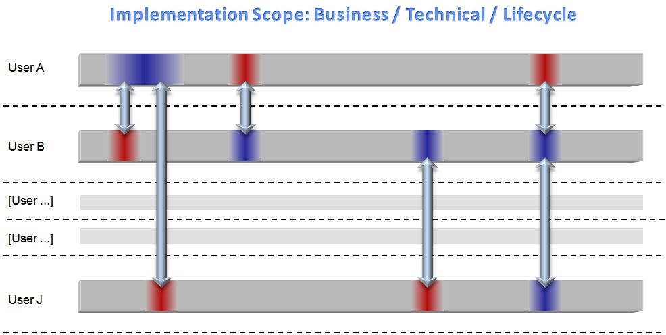

If their PLM Teams could talk to each other in detail, over time, then by swapping ideas and methods they would pass solutions to each other, to everyone’s benefit.

So, in the diagram, User J would pass its more advanced knowledge to Users A and B, and would be helped with another issue by User A. User B would help with a problem of User A, and be helped in turn by Users A and J; and so on.

However, in the real world, few people have time to do this on a sustained basis, and also the technical analysis is very difficult to do.

PLM 2025-35 solves this by providing a working framework that everyone can fit into.

Framework
The PLMIG structures and manages the whole PLM 2025-35 programme, providing tools, documentation and technical input for all of the User companies.

Over the course of the 12-month programme, the PLMIG actively facilitates the sharing of knowledge between user PLM Teams described in 4.1.

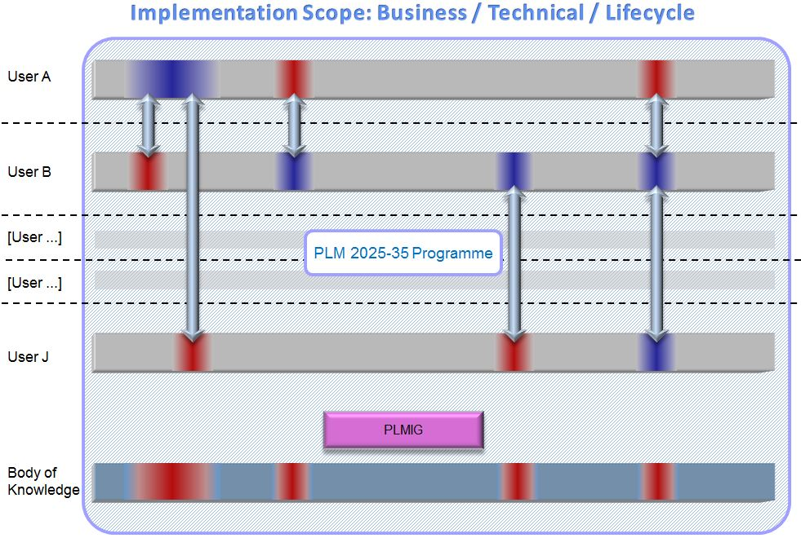

Every user participant receives the same tools, carries out the same internal analysis, and identifies its areas of focus. The PLMIG manages the harmonisation and calibration, and then runs workshops to resolve the specific issues requested by the users.

The findings are documented in a way that enables the users to apply them, and also distilled into a neutral format to be reviewed by the Knowledge Development stream.

The outcome is that all of the user companies go from ‘blue’ to ‘red’, confidently applying the new best practices across their implementations; and the kernel of the Body of Knowledge is built from the real-world conclusions.

METHODOLOGY

User Collaboration
The timeframe shown here is 2026, but the 12-month plan can start at any convenient time.

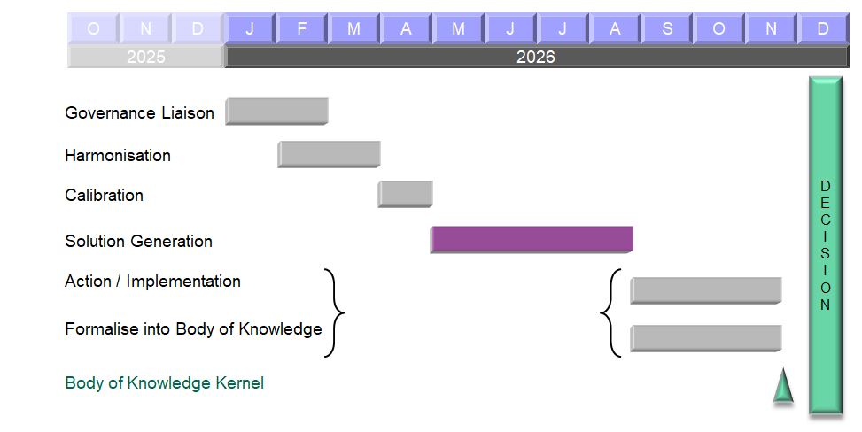

The first step is for all of the participants to get aligned, so that meaningful conversations and comparisons are possible. It begins with Governance Liaison, using the PLMIG Self-Assessment and Benchmarking tools to produce Navigation Models that show the emphasis of each implementation. This is likely to be the first time that the PLM Teams have ever been guided in what they do, and will raise the concept of ‘good management discipline’.
In Harmonisation the questions and ideas are discussed and rationalised by the participants, in what is in effect a “trade show on steroids”. Calibration rationalises this and positions everyone for the detailed work.
The core of the whole project is Solution Generation, in which the PLMIG uses its workshop expertise to produce solutions for the specific problems , issues, and future capabilities that the participants have requested. The documentation, and new tools if applicable, are then Actioned within each implementation with PLMIG support.
While providing these direct solutions the PLMIG also distils the findings into a neutral format to be reviewed by the Knowledge Development stream and formalised into the first live version of the Body of Knowledge.

Knowledge Development
The Knowledge Development stream runs in parallel with the User Collaboration, and is just as important.
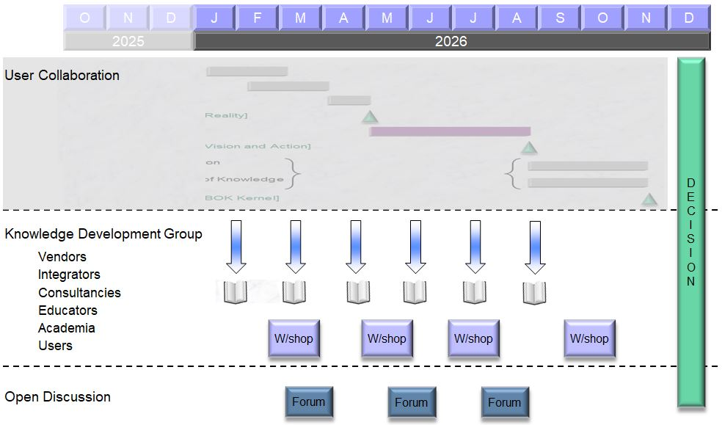

Consisting of a formal group of PLM organisations of any type, with the capacity and resolve to help construct the new model, the Knowledge Development participants receive a regular information feed of documentation and neutral learnings. PLMIG workshops enable them to review and expand upon this and to generate the actual Body of Knowledge content.

Although it is not shown on the diagram, the Knowledge Development findings are iterated into the User stream to improve the results generation and to maintain a positive feedback cycle.

There will also be an Open Forum discussion process to allow individuals, pundits and the press to get visibility of the process.

AI WORKING GROUP
A small but very important part of this Project concerns the use of AI in PLM.

AI is widely misunderstood, and its PLM context needs to be made clear. The risk is that it can become a complete distraction from meaningful progress. Current AI is a very specialised application of a tiny technical subset of overall knowledge management - so narrow, in fact, that the computer still doesn't 'know' anything. It just presents some paragraphs of text.

Even this unknowing version of AI has its uses, but it is not what PLM needs. PLM is managed by real, experienced people with a shared understanding, specialised skills and everyday human interaction. Experienced people who understand the business, the marketplace and have aims for the future. The development of a PLM Body of Knowledge is all about genuine knowledge, that stays in place and can be used over and over again.

Some AI will be necessary and useful - not in creating the Knowledge (that comes from User Collaboration): but as a sort of "tour guide" or instructor that shows practitioners where to find the material they need and how to apply it in their live, day-to-day environment.

We need to know exactly what form this should take, and so we will include a Working Group to produce a definitive AI tool for PLM - if such a thing is possible.

The Working Group will define a solution that is better, more accurate, and more constructive. It will answer questions such as what, exactly, do manufacturing companies want? What are the specific requirements of PLM? How do you control the dataset, and what happens when different companies combine their own set with each other or with the Body of Knowledge? How do you check the outputs for accuracy? How do you manage the outputs when they are written into documents which have their own circulation? Which of the available engines is most useful? Can any of the engines be made to work in the way that we need?

The really interesting aspect is that the Working Group will also go further than this. Academic research in the 1990s into Knowledge Management (how to capture what someone knows, so that you keep the knowledge when they leave; and how to think like a human being) was far more advanced than today's offerings. It failed at the time because the 'Rolls-Royce' solution was too difficult to do, but the findings still exist and there are now tools that could achieve 80% of those benefits with 20% of the effort.

There are two streams in PLM 2025-35 (User Collaboration and Knowledge Development) and members of the AI Working Group can come from either of them. Anyone who is part of the Project can opt in. This allows participants to learn about serious AI as the Project unfolds, but mainly it enables the advanced practitioners to combine their expertise within a structured and well-managed framework.

No-one has done this before from a PLM prospective. The results could be ground-breaking for everyone. Over the 12-month period we will either set it up and demonstrate it, or prove that it cannot be done - and if so, spell out the alternative approach that works.

BODY OF KNOWLEDGE ISSUES
The PLM 2025-35 Project solves a number of inherent problems that lie in the way of creating a genuinely comprehensive Body of Knowledge:-

Problem | - | Solution
“The content will be massive, and not all of it may currently be known.” | - | The Project will start with what is immediately useful and grow from there. The workshop process will generate new knowledge if it is required.
“The BOK will have to cover high-level business concepts and arcane technical details.” | - | The project structure and method allows all aspects of PLM to be covered.
“Every business that will use the BOK has its own PLM context, and sees PLM differently.” | - | The business context of the BOK will be derived from the real-world contributors.
“The BOK needs to be agnostic and non-denominational: truly neutral in its content and presentation.” | - | The Knowledge Development stream makes the results non-denominational.
“Users of the BOK need to know ‘What to Do’ – how to apply the knowledge that they are being shown.” | - | The Application stage of the Project will show ‘What to Do’ and how it works.
“A global BOK should be available for everyone, but it takes time and funding in order to create it.” | - | The first 12-months are the start-up, so the creators in the two stream will own the BOK in de facto terms. They will then decide on Year 2.

PLMIG SUPPORT

Management
This is a participatory project, designed to run with a minimum of effort and overhead for the participants. The PLMIG provides the tools and the structure; participants receive the material and join in with the actions at each stage, contributing to the findings; and the PLMIG provides the published results.

Tools
The PLMIG provides all of the tools and working documentation for the project, together with direct support for participants as they are used. In the opening ‘Harmonisation’ stages these will be for Self-Assessment and Benchmarking; and in the ‘Solution’ stages they may include any of the multiple handbooks and manuals that the PLMIG has developed over twenty years.

The PLMIG also sets up and runs the on-line workshops designed to produce the specific problem solutions, and publishes the findings for follow-on use.

Workshops
There will need to be specific working meetings to investigate and analyse the detailed issues that the user participants want to work on. The PLMIG has extensive experience in running such workshops to produce accurate and useful findings, and the project members who are interested in each particular issue can take part.

Documentation
In addition to the direct project documentation the PLMIG will produce all of the neutral, ‘distilled’ documentation for the Knowledge Development team to work on, and will construct the eventual written Body of Knowledge.

Coordination
Once the mobilisation phase has been completed, PLM Teams from different organisations will be talking to each other in much more detail than has previously been possible. When PLM practitioners get together in this way they generate their own ideas. It is expected that participants may hold local discussions amongst themselves, as part of the general activity of a community.

This is to be encouraged, subject to confidentiality, and findings or actions from these interactions can be fed back into the centralised coordination if required.

HOW TO TAKE PART
PLM 2025-35 is designed to be an informal and flexible project that is easy to be involved with and to benefit from. The Conditions of Participation are therefore minimal:-

1. Membership of the Project commences on receipt of the Membership Fee, and will last until the completion of the 12-month project schedule. The User Collaboration and Knowledge Development streams have the same fee of $10,000 (€8,500, £7,400).

2. User organisations are eligible to join the User Collaboration stream, and should be willing and able to participate in its activities. The internal discussions of the UC members are confidential, and any documentation published outside the stream will be neutral and non-attributable. The detailed focus of this half of the project will be decided by its members.

3. Organisations of all types are eligible to join the Knowledge Development stream, and to participate in generating the Body of Knowledge. The internal discussions will be confidential, and the published documentation will be in the proposed neutral format.

4. New Members may join at any time by payment of the same fee, and their membership will run until the completion of the 12-month schedule. It is not expected that the Groups will become so large that they cannot function.

5. No specific practical, financial or legal liability is attached to Project Membership.

6. For the first 12 months (as covered by this Proposal) the Body of Knowledge will be entirely in draft form, with the first release at the end of the project period. The PLMIG and the project members will therefore own it collectively while it is under this development. As publisher, the PLMIG will retain the copyright, and make it available to every project member.

7. At the end of the 12 months the PLMIG and project members will decide whether the Project should continue in its current form, and how the Body of Knowledge should be further developed.

8. PLMIG tools and material, and new material produced by Project activity, are confidential to Members. Participants are encouraged to reproduce, modify, or take extracts from any part of it for their internal use. The PLMIG may compile some of the ongoing draft documentation into new tools which will then become available as part of general PLMIG Membership.

Participants in both streams will receive all of the current PLMIG toolsets, and all of the new tools produced during the 12 months of the Project, as part of their Project Membership.

PRE-REGISTRATION
Before the Project launches we need to give everyone a clear picture of the collaboration group, and the 'Wish List' that we aim to resolve. 12 months of combining experience with other PLM Teams is very beneficial, if the solutions include ones that are relevant and useful to you.

We are therefore holding some Round Table discussions, and you can join in by Pre-Registering. There is absolutely no cost, obligation or commitment involved, but we need the views of people who may want to shape the Project.

Pre-Registration keeps you in the loop as the Project comes together, allows potential participants to get to know each other, and should also show an interesting picture of where practitioners think PLM improvements should be made. Feedback from these discussions will be used to inform and update the Proposal before the Project starts.

This is an international project - you can take part no matter where in the world you are based. It may even be a way of learning about concepts of PLM that are outside your organisational or national boundaries.

Companies can pre-register up to 3 people to be part of these discussions, in one of the three themes:-
- User Collaboration Stream
- Knowledge Development Stream
- AI Round Table

All you need to do is to complete the Participation Form overleaf and return it (or this document) to plm2025-35@plmig.com.

.../over

Participation Form

Please register the following delegates for the PLM 2025-35 Pre-Registration discussion.

Which Stream?
User Collaboration | ? | Knowledge Development | ? | AI | ?

Delegate #1 (primary contact)
Name
Company
Job Title
Country
Email

Delegate #2 (if required)
Name
Job Title
Country
Email

Delegate #3 (if required)
Name
Job Title
Country
Email

Please send these details to plm2025-35@plmig.com or contact Roger Tempest on +44 1865 880495.

Briefing information will be sent to you by return.

