





PLM Interest Group

state of plm 2026

REPORT

An explanation of how PLM evolution has failed to match the needs of modern manufacturing, and suggestions for further action.

Version 1.0

08 June 2026

PROLOGUE
The origins of this Report sprang from the best of intentions – the desire to create a formal, recognised profession for PLM practitioners that would enable them to become qualified, progress through their careers and be given the respect that they deserve by colleagues from other disciplines.
The PLMIG began a series of Panel Meetings in January 2025 in order to progress this theme, but by May they had hit a problem: in order to define skill sets and qualifications it is necessary to capture and codify best practice, but ‘best practice’ was nowhere to be seen.
The PLM industry, intrinsically, had not developed at all over the previous two decades, and any “progress” (and there was much to be seen and talked about) was in fact based on technology developments in the wider world that PLM was absorbing.
PLM needed some direction and a Vision for the next 10 years, and so the drive for a Profession was paused and the PLM 2025-35 Project was created to address this problem.
At first, attention was focused on the potential creation of a PLM Body of Knowledge (solving the ‘best practice’ issue); and on how to position and adopt AI (solving the ‘huge distraction’ issue); but then industry veteran Doug Macdonald stepped up and declared that the way that PLM tools have evolved is also part of the problem.
Suddenly, the progress and future direction of PLM were back on the table. Is he right? If he is then PLM user companies around the world, from SMEs to the largest global corporations, are wasting time, resources and money on inadequate solutions.
On Tuesday 02 June the PLMIG hosted the State of PLM Debate to work through this premise. Doug gave a Keynote presentation to expand on it; the group debated the issues around it; and this document is the Report.

Table of Contents
1 PROLOGUE 2
2 KEYNOTE 4
2.1 Tangled History 4
2.2 Fitness for Purpose 5
2.3 Desired Future Platform 6
3 IS THE PREMISE CORRECT? 8
4 IMPLICATIONS FOR PLM 9
4.1 Re-Evolve or Rebuild 9
4.2 Minimise Complexity 10
4.3 Evidence of Success 10
5 PLM BLUEPRINT 11
6 FUTURE PLM STEERING GROUP 11
7 Feedback 11

KEYNOTE
Doug Macdonald is a PLM industry veteran who started his career in the 1980s at ICL, in the earliest days of CAD and NC programming, and worked at companies including Computervision, Sherpa, PTC, SAP, Aras and CIMdata.
He therefore has an insider’s view of the entire evolution of PLM as we know it today, and he is uncompromising in his conclusions. As one participant commented: “I much appreciate this session and the sober perspective from someone this experienced.” And his perspective is sober indeed.
PLM is portrayed like the fabled Wizard of Oz, wielding all-powerful control over the product lifecycle, but everywhere the reality falls short of this. When you look at PLM closely it is fragmented and full of manual intervention, like the man behind the curtain.
His Keynote pulled no punches: “At the end of this presentation you will have a choice: you can throw your PLM plans out of the window and start over, or you can doom your company to a continuing struggle with broken processes built around a legacy technology”.

Tangled History
The story starts back in the 1980s. CAD systems like CADDS from CV, CATIA from DS, and Unigraphics from UGS were being rolled out rapidly. Industrial companies were soon struggling to manage the large amounts of data being created. Enter the first generation of PDM systems, designed to index and store CAD files and make it easy to find and retrieve them
By the 1990s PDM was a fast-growing market. MatrixOne and Agile launched mid-decade, and large CAD vendors built or acquired their own PDMs: UGS → IMAN; SDRC → Sherpa, later Metaphase; Dassault Systèmes → Product Manager (from IBM partnership); PTC → Pro/Intralink, and later Windchill.
The early 2000s saw further consolidation: UGS acquired SDRC merging IMAN and Metaphase into Teamcenter; Siemens acquired UGS; 3DS acquired MatrixOne, rebranding it as Enovia. Aras, Arena, and Propel emerged but failed to make a significant impact on the market. SAP and Oracle (which had acquired Agile) entered the market but have not made PLM prominent in their portfolios.

In short, The Big 3 have spent the last 20 years focused on rebranding, re-hosting, and re-monetizing but not addressing the coverage gap. Integrations to other systems are typically built by 3rd parties and are affordable only by bigger companies. “Digital Threads” and “Digital Twins” are new names for old capabilities. The rush to incorporate AI is underway, but PLM systems of today are little changed from PDM of the 1990s.
Today’s engineering ecosystem is characterised by broken processes built on legacy technology: Tens of thousands of hours lost every day searching for and recreating information; poor collaboration across technical disciplines dragging out development time; broken downstream communications raising costs and delaying product launches; and the realization that Legacy PLM is not the place to start deploying AI.

Fitness for Purpose
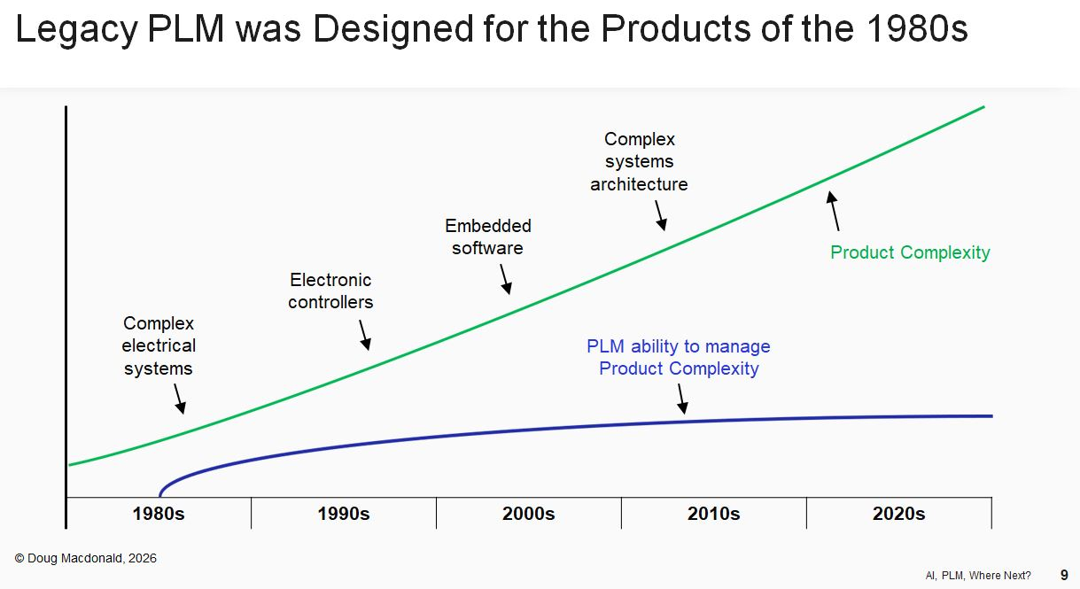

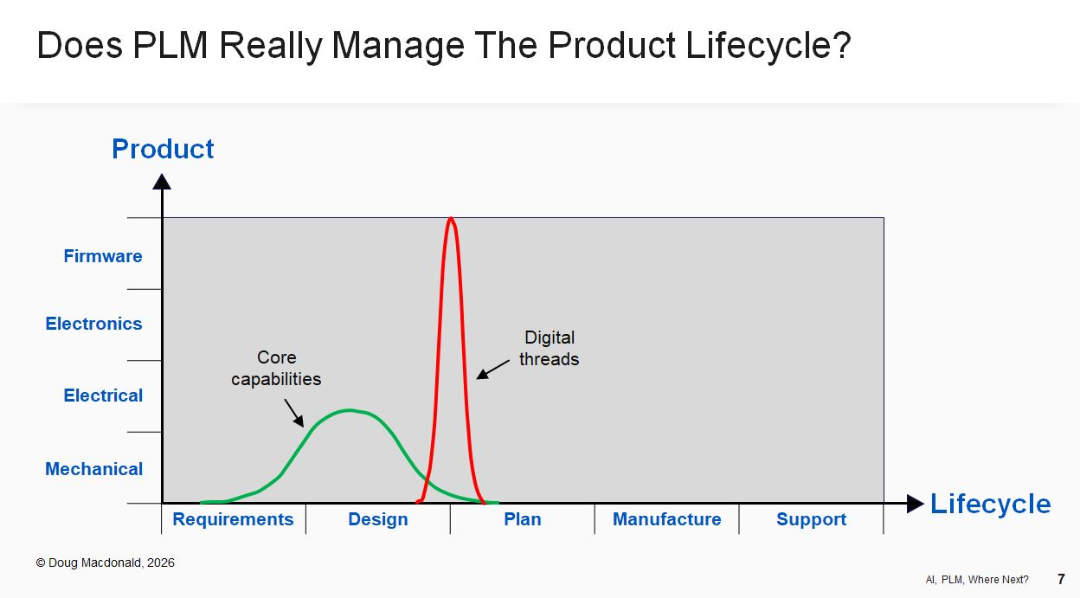

The marketing story is that PLM gathers all product information using digital threads into a “single source of truth”. PLM connects all users of product information, allowing them to share information. PLM allows us to create digital twins of our finished products. PLM is critical for optimizing your manufacturing and planning processes with a complete Digital Twin and MBE, ensuring that all stakeholders work in a collaborative software environment using enriched data sets...
Whereas, instead, PLM systems are focused on managing MCAD files and associated BOM and release processes. There are limited integrations to other products the vendor owns, but often just for BOM management. This means that companies that want an integrated ecosystem for complex products must build it themselves – and the results are usually complex, fragile, and beyond the means of all but the biggest. Companies end up filling the gaps with spreadsheets, Slack, and email.
Meanwhile, products themselves have become vastly more complex. An electric toothbrush in the 1980s had a motor, a battery and a switch. Today it has a printed circuit board, microprocessor, a choice of programmed head speeds, and an internet connection to a phone app that displays your brushing habits. Mainstream PLM systems on the market today just cannot cope with this.

Desired Future Platform
Doug foresees a future platform that will embrace the scope of the complete product and the full lifecycle, with:-
- A hub and spoke integration architecture with integration to a wide range of systems (MCAD, ECAD, Dev Tools, ERP, MES, MBSE, PDM, QMS, PLM, PPM, Simulation, Procurement, Requirements);
- A structured ontology that normalizes entities, attributes, relationships and operational semantics across systems;
- Automated workflows to trigger the transfer of information between systems including digital twins;
- Integrated applications to perform cross-discipline functions such as BoM and change management;
- AI-ready architecture allowing managed agent access to governed data.

Its key characteristics are that it connects engineers working in every discipline (electrical, electronics, software, wireless), every function (development, test, procurement, manufacturing, service) and every system they use (CAD, simulation, coding tools, MES, ERP, etc.).
It uses AI to continuously support engineers by automating repetitive processes. For example, BOM configuration and change management is enriched with the knowledge of interdependencies with other parts/activities/requirements allowing it to be automated and agent-driven, with engineers performing final review. Other repetitive processes helped by AI include verifying designs against requirements, conducting manufacturing feasibility reviews, placing part orders, creating user and service manuals, investigating service reports, etc.
All user interactions go through this new platform (no more Email or Slack), allowing all decisions to be recorded, and all information to be directly accessed (no more Excel, PDFs, STEP files). Iteration and feedback loops run faster and design speed increases, surfacing risks early, avoiding errors, and ultimately reducing cost and time to market.

IS THE PREMISE CORRECT?
While one might challenge the extent that the major PLM applications are still focused on CAD, there is no doubt that the overall situation is as Doug described. The evidence is everywhere, including (as mentioned in the PROLOGUE) the fact that the drive for a PLM Profession has had to be paused until these basic problems are resolved.
When PLM first stirred in the 1980s it was a surprise to everyone. Nobody outside the IT department knew about computers, and it all began with some very interesting and heated arguments with draughtsmen about not marking up paper prints and sending them to suppliers – something they had been happily doing for years. Those issues were all brand new, and we learned as we went along.
And that, basically, is what we have been doing ever since. Learning as we go along. For over 30 years, without any industry cohesion or direction, we have been following an evolving set of concepts on the back of product development paths of vendors that are competing with each other.
Meanwhile, manufacturing and technology have made their own huge advances, to a point where the current PLM solution set that everyone relies on is not fit for purpose.
It used to be thought that PLM was incomplete, or still on the journey, because the tools had not yet been applied throughout the organisation, and because there were legacy systems that had not yet been absorbed.
Now it is clear that PLM will never be complete unless the toolset is re-imagined, and this has massive implications for the way that we look to the future.

IMPLICATIONS FOR PLM
This all means that PLM needs a rethink, from the ground up. It is behind the curve of modern manufacturing and will never catch up unless we review what it is for, and how that is achieved.
This is not just about the tools. The whole concept of PLM has become very fragmented, and implementation aims and benefits have become vague. Everyone in the industry can be part of this re-appraisal.

Re-Evolve or Rebuild
If we take a wider view, then PLM is not the only historical problem. The fact that PLM is separate from ERP is also an evolutionary mistake.
The reason is very similar. The two disciplines, and their associated IT platforms, evolved separately. ERP evolved from the manufacturing systems that companies needed to control their operations, and PLM from the systems that companies needed to control their designs.
This has meant that, in organisations that implement PLM and ERP, they generally exist as two separate functions, with two separate support teams, competing with each other for resources.
If we could start now, armed with all our knowledge and technology, we would create neither PLM nor ERP. We would build one single Product Management system for the entire enterprise, that manages the data from its first inception right through the manufacturing and build to field service and support.
Of course there are other disciplines that are also part of whole-enterprise, whole-lifecycle product management, but the principle extends to include them.
Everything about the product would be in this same Product Management system: requirements, configuration, sourcing, all the various incarnations of BOM, customer discounts, serial numbers, field performance and quality improvement. Whatever you wanted to know about the product, it would be here.
There would be no skills divide, and no competition between PLM and ERP for funding. Data, communication and application would be fundamentally integrated.
This only a concept, and may not be achievable, but if we are rethinking what PLM is for then this advanced scenario is good to bear in mind.

Minimise Complexity
In theory there are two potential routes forward. One is that vendors upgrade their solutions, successor products are added, and perhaps AI becomes a help. This increases the overall system complexity, but the solutions themselves manage it and are therefore easier to control.
The other is that there is a rebuild of what PLM should be, supported by the creation of better software solutions that do not exist yet. The new solutions are more accurate and comprehensive, making things inherently simpler: but that would turn current PLM systems into legacy systems, which creates a new layer of complexity.
The PLM Team’s working environment is complex enough already, with legacy platforms that never seem to go away, and information leakage into spreadsheets, email and direct messaging. The concept of ‘Minimum Complexity’ is worth keeping in mind as we start to look at future improvement.

Evidence of Success
The shortcomings of PLM evolution are made clear every time a user company runs a selection exercise. It becomes a ‘beauty parade’ of four or five highly proprietary proposals, all of which are different and none of which are what the company actually wants.
This is really frustrating, because it takes a lot of effort and preparation to think through all the PLM needs and produce an Invitation to Tender. At this point there is a clear vision of what benefits should come from the new PLM, and how it will all mesh into future operations.
But disappointment follows. One can only buy what is being sold, so the company has to opt for the one that is least distant from their needs and that can be covered by the budget.
What should happen, if PLM had evolved properly, would be that there are 4-5 bids that all meet the defined needs, albeit by various different means; allowing you to match alignment with aims, ease of adoption, functionality and cost.
To achieve this future scenario, and decide whether to re-evolve or rebuild, we need an industry-wide PLM Blueprint.

PLM BLUEPRINT
A Steering Group will be formed representing all parts of the industry, and over the course of 12 months it will develop a written PLM Blueprint.
This PLM Blueprint is not a three- or four-page white paper but a comprehensive document incorporating all of the new thinking, and spelling out the advanced scenario that will meet the needs of modern manufacturing into the mid-term future.
At the end of the Project it will be globally available, and thus will be on the table at every major PLM selection. It is only natural that User companies will use it as part of the process.
So, along with the specific requirements, a question for every vendor that responds to the Tender will be: “How does what you are proposing support or differ from the Blueprint?”.
Over time the Supply Side will adapt, and PLM will become what Users want.

FUTURE PLM STEERING GROUP
Whether it is right or wrong, the current PLM landscape is entrenched. The only way to make change happen is to make the required future scenario so clear and authoritative that providers have to react to it. That is the role of the Steering Group.
This is not an anti-vendor diatribe. It is an open and structured review of where PLM is, and where it ought to be. The Steering Group will be part of the PLM 2025-35 Project, and it is open to organisations from all parts of the industry. Users, vendors, integrators and consultancies all have a stake in the future of PLM and should all have an influence on the way that it changes.
If anything, we are creating a ‘Voice of PLM’ through which people from all around the PLM industry can finally say where it ought to be going. If you have been thinking for a while that PLM should be better than it is, are tired of the shortcomings that keep downgrading the outcome, and have ideas about how things could improve, then the Steering Group provides the platform to shape that future.

Feedback
Development of the Steering Group is ongoing, and you can find more information (or send questions or feedback about this Report) to plm2025-35@plmig.com.

